JOINS AND SET OPERATIONS

Name: Ch.Srihitha
Roll No: 2520030400

Step 1 — Create and Select a Database
CREATE DATABASE joins_db; USE joins_db;

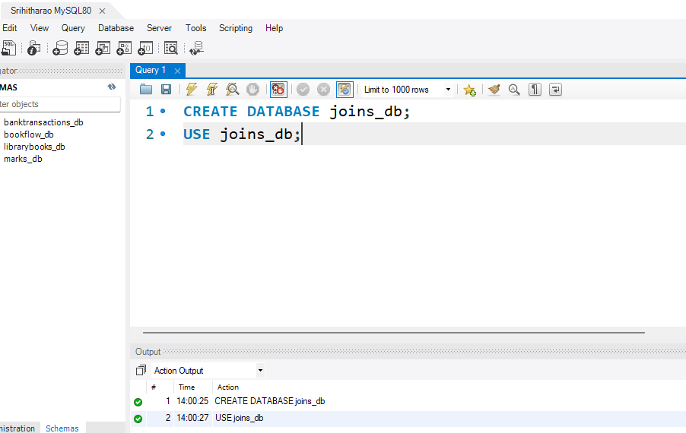

Step 2 — Create the Tables (class, class_info)
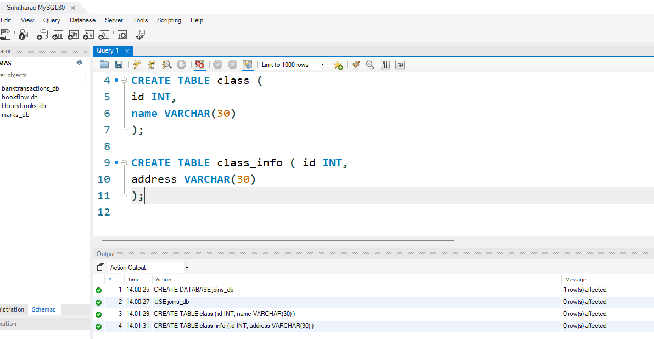
CREATE TABLE class (
id INT,
name VARCHAR(30)
);

CREATE TABLE class_info ( id INT,
address VARCHAR(30)
);

Step 3 — Insert Data
Query:
INSERT INTO class VALUES
(1,'Srihitha'),
(2,'Maha'),
(4,'Meghana');

INSERT INTO class_info VALUES (1,'DELHI'),
(2,'MUMBAI'),
(3,'CHENNAI');

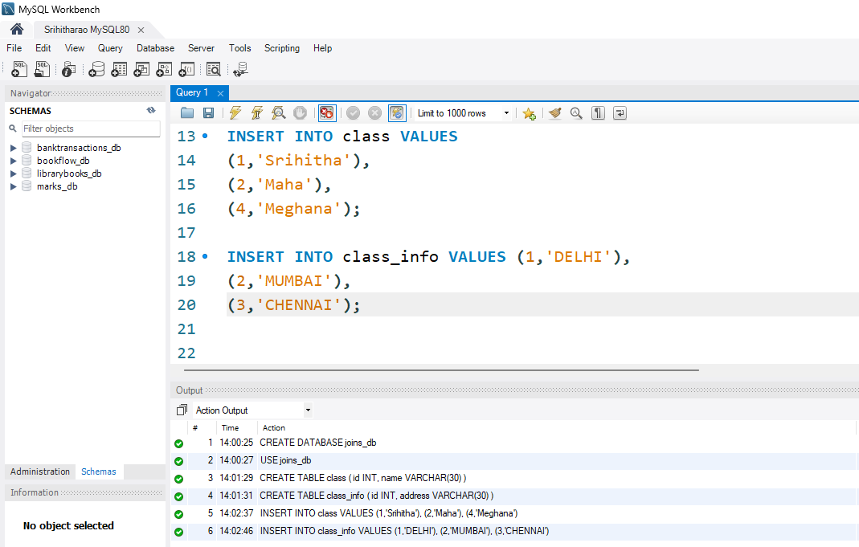

Step 4 — Question 1: CROSS JOIN
SELECT *
FROM class
CROSS JOIN class_info;

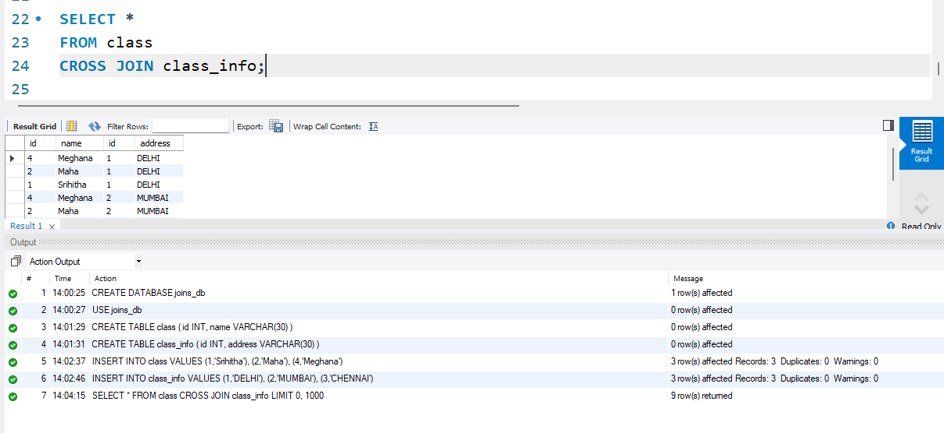

Step 5 — Recreate Tables for INNER JOIN Section
Query:
DROP TABLE class, class_info;

CREATE TABLE class (
id INT,
name VARCHAR(30)
);

CREATE TABLE class_info ( id INT,
address VARCHAR(30)
);

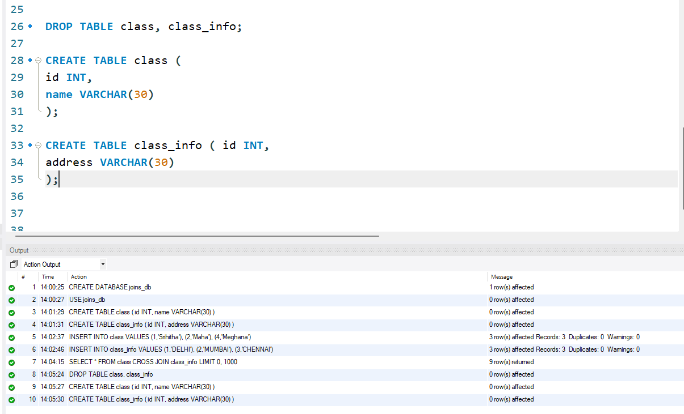

Step 6 : Insert Updated Data
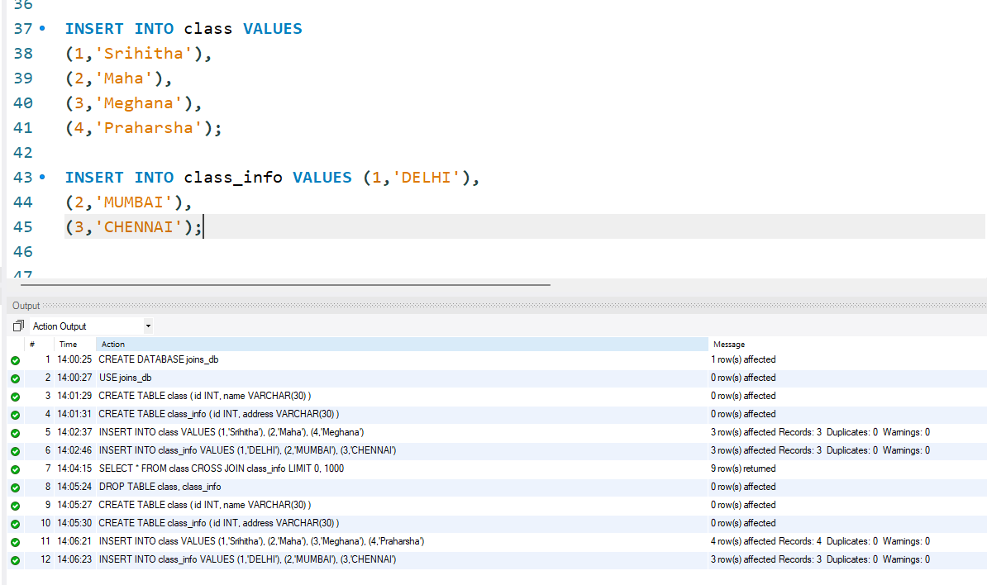
INSERT INTO class VALUES
(1,'Hansika'),
(2,'Hasini'),
(3,'Bindhu'),
(4,'Anusri');

INSERT INTO class_info VALUES (1,'DELHI'),
(2,'MUMBAI'),
(3,'CHENNAI');

Step 7 — Question 2: INNER JOIN
SELECT *
FROM class
INNER JOIN class_info
ON class.id = class_info.id;

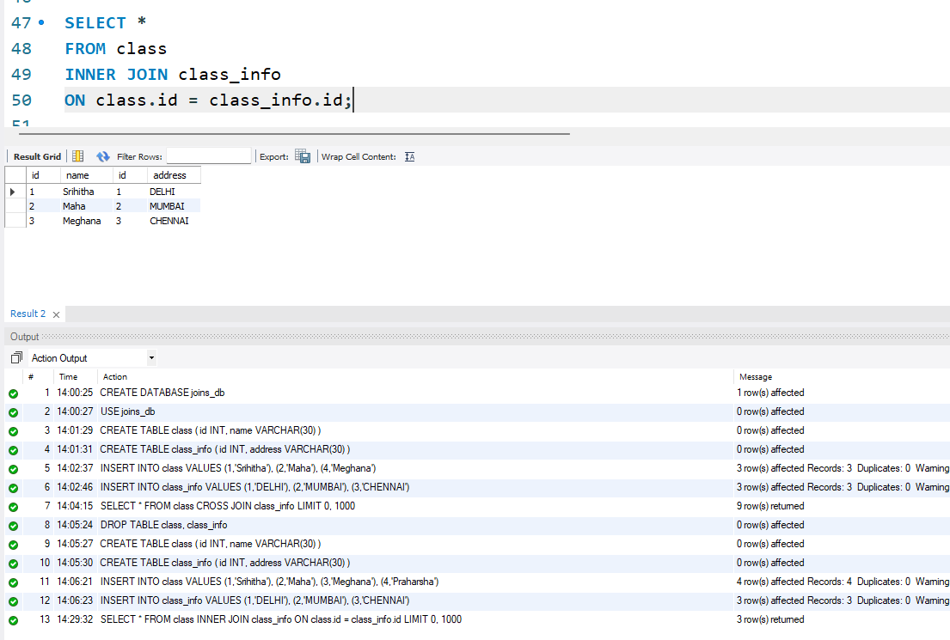

Step 8 — Question 3: INNER JOIN (Selected Columns)
SELECT class.name,
class_info.address FROM class
INNER JOIN class_info
ON class.id = class_info.id;

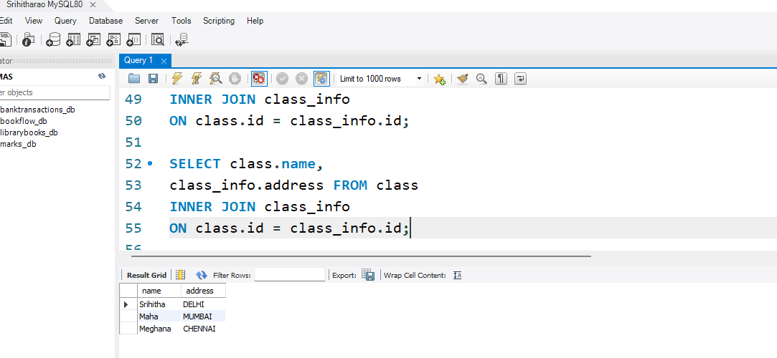

Step 9 — Question 4: NATURAL JOIN
Query:
SELECT *
FROM class
NATURAL JOIN class_info;

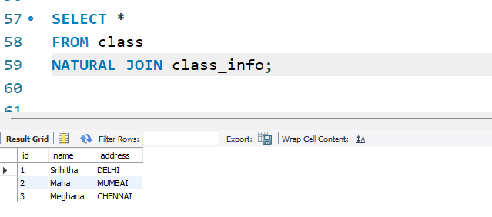

Step 10 — Insert Extra Rows for Outer Join Section
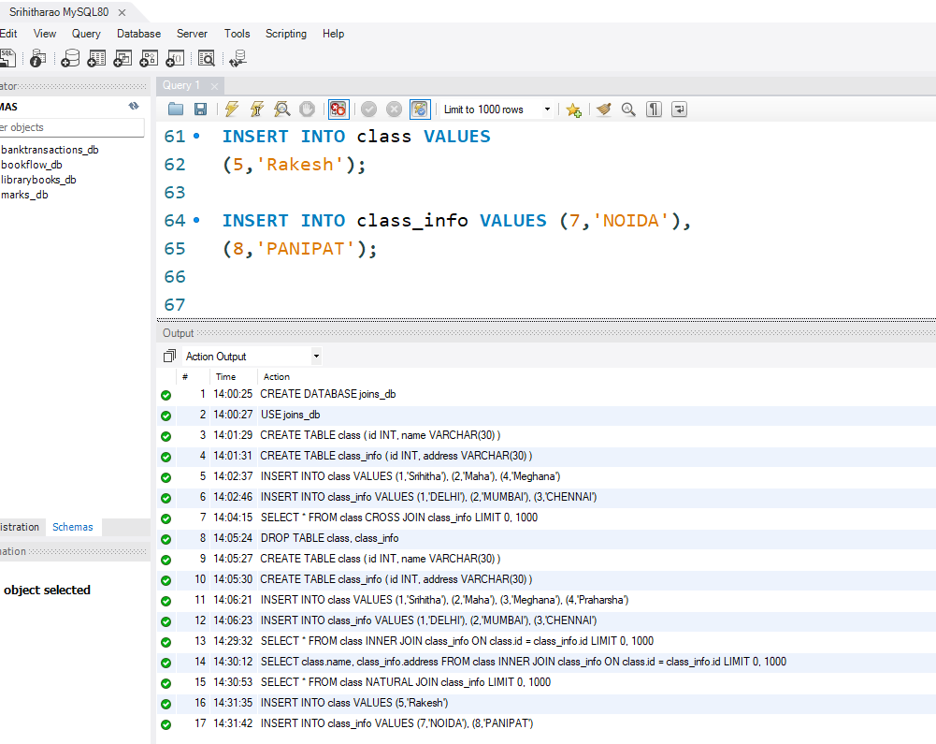
INSERT INTO class VALUES
(5,'Rohan');

INSERT INTO class_info VALUES (7,'NOIDA'),
(8,'PANIPAT');

Step 11 — Question 5: LEFT OUTER JOIN
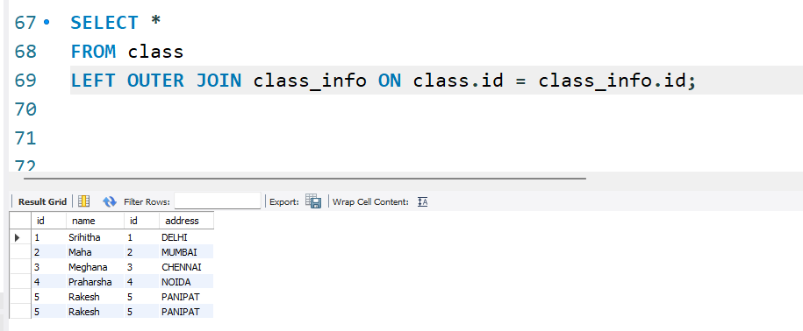
SELECT *
FROM class
LEFT OUTER JOIN class_info ON class.id = class_info.id;

Step 12 — Question 6: LEFT JOIN (Unmatched Only)
Query:
SELECT *
FROM class
LEFT JOIN class_info
ON class.id = class_info.id WHERE class_info.id IS NULL;

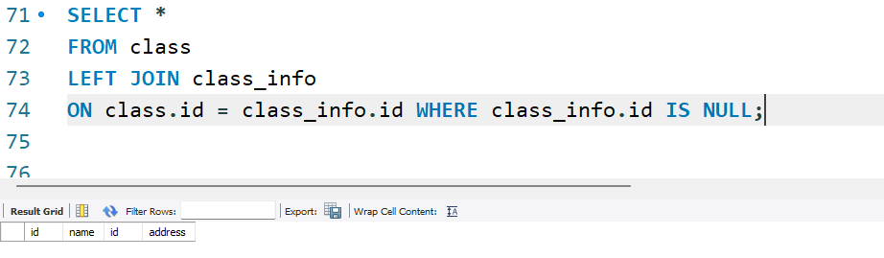

Step 13 — Question 7: RIGHT OUTER JOIN
SELECT *
FROM class
RIGHT OUTER JOIN class_info ON class.id = class_info.id;

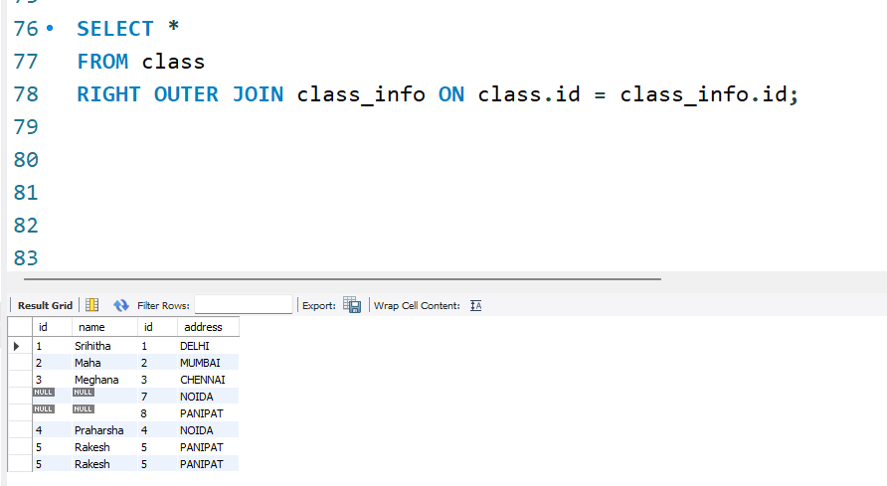

Step 14 — Question 8: RIGHT JOIN (Unmatched Only)
SELECT *
FROM class
RIGHT JOIN class_info
ON class.id = class_info.id WHERE class.id IS NULL;
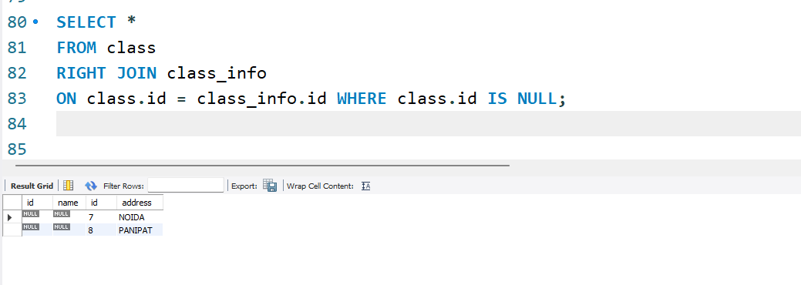

Step 15 — Question 9: FULL OUTER JOIN
Query:
SELECT *
FROM class
LEFT JOIN class_info
ON class.id = class_info.id UNION
SELECT *
FROM class
RIGHT JOIN class_info
ON class.id = class_info.id;

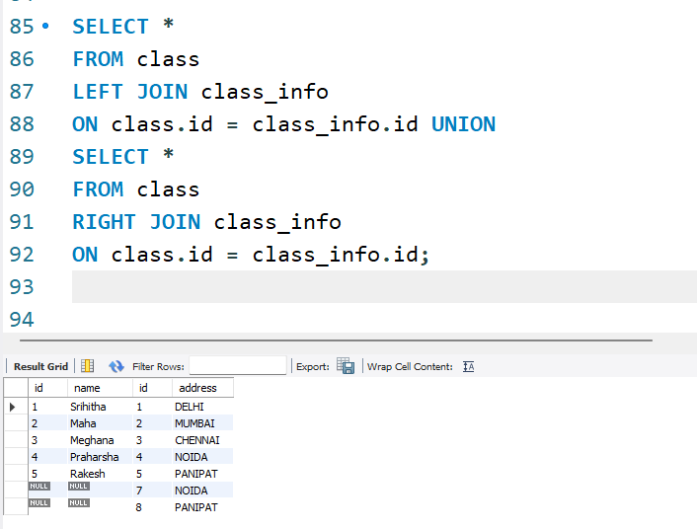

Step 16 — Question 10: FULL OUTER JOIN (Unmatched Only)
Query:
SELECT *
FROM class
LEFT JOIN class_info
ON class.id = class_info.id WHERE class_info.id IS NULL UNION
SELECT *
FROM class
RIGHT JOIN class_info
ON class.id = class_info.id WHERE class.id IS NULL;

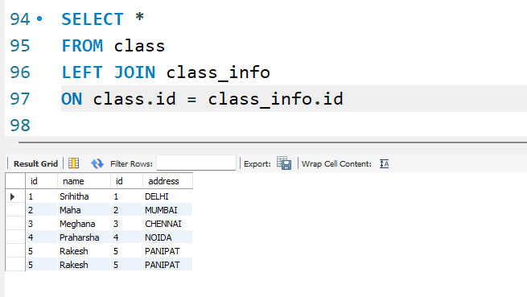
Step 17 — Create first_table and second_table (for UNION section)
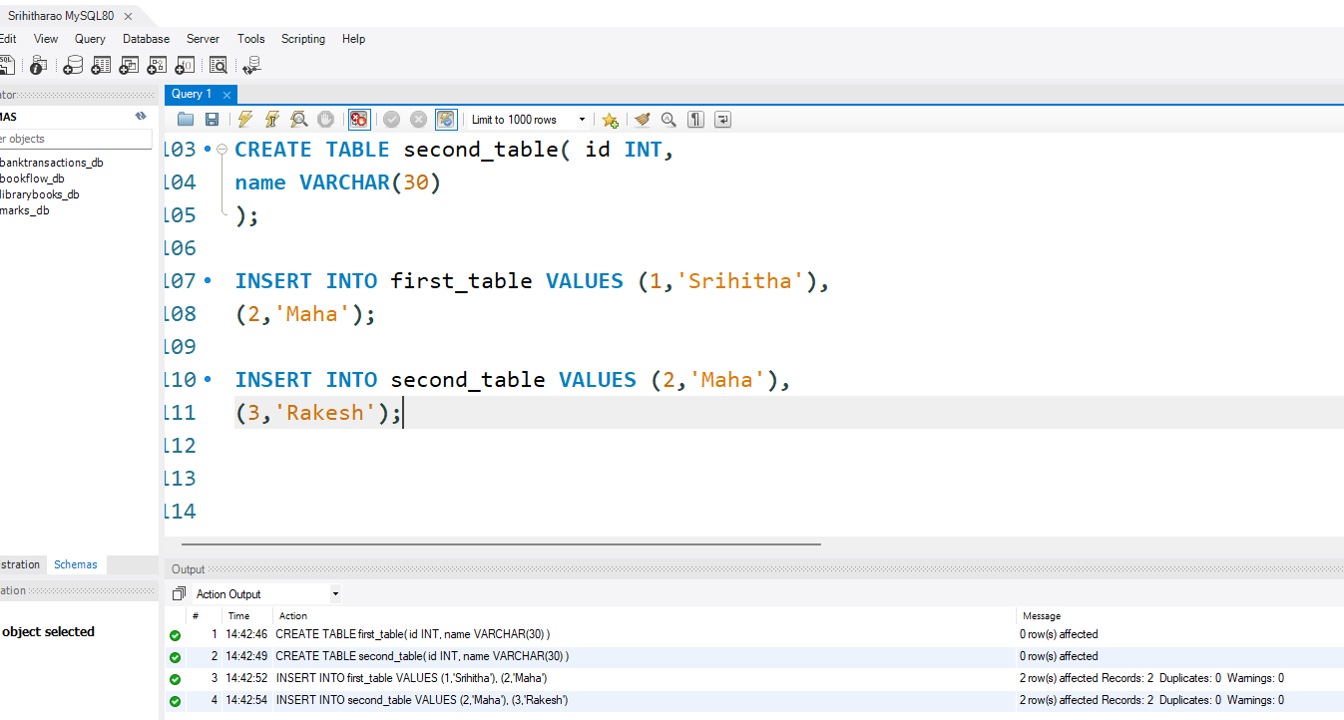
CREATE TABLE first_table( id INT,
name VARCHAR(30)
);

CREATE TABLE second_table( id INT,
name VARCHAR(30)
);

INSERT INTO first_table VALUES (1,'Srihitha'),
(2,'Maha');

INSERT INTO second_table VALUES (2,'Maha'),
(3,'Rakesh');

Step 18 — Question 11: UNION
SELECT * FROM first_table UNION
SELECT * FROM second_table;

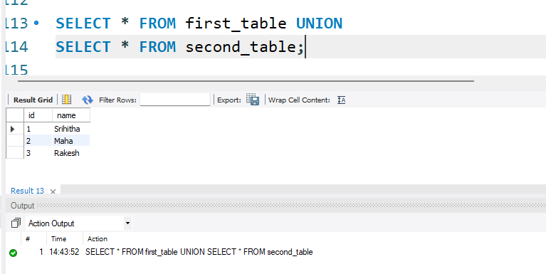

Step 19 — Question 12: UNION (Names Only)
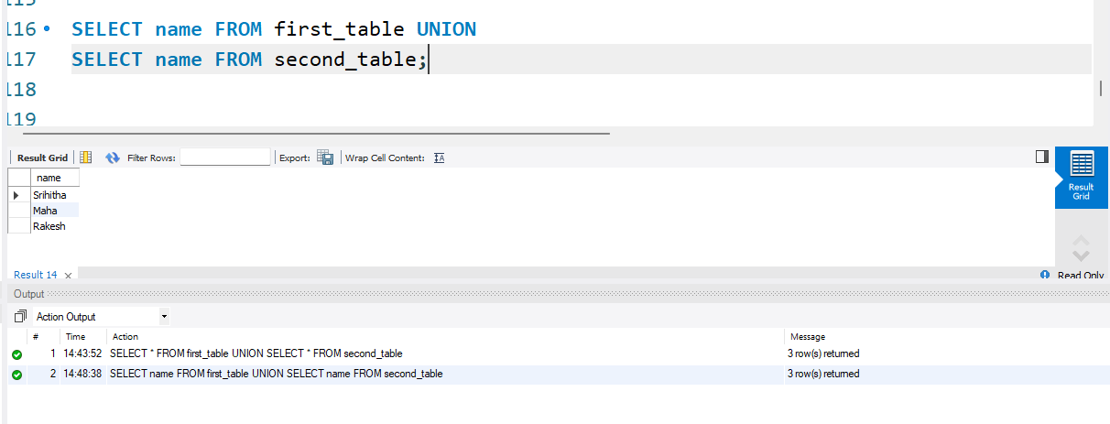
SELECT name FROM first_table UNION
SELECT name FROM second_table;

Step 20 — Question 13: UNION ALL
SELECT * FROM first_table UNION ALL
SELECT * FROM second_table;
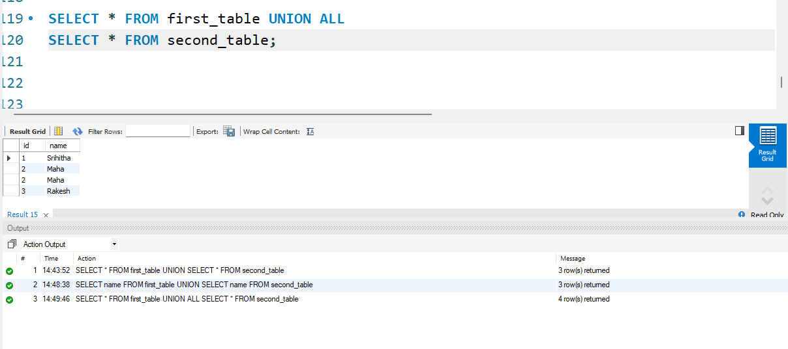

Step 21 — Question 14: UNION ALL (Row Count)
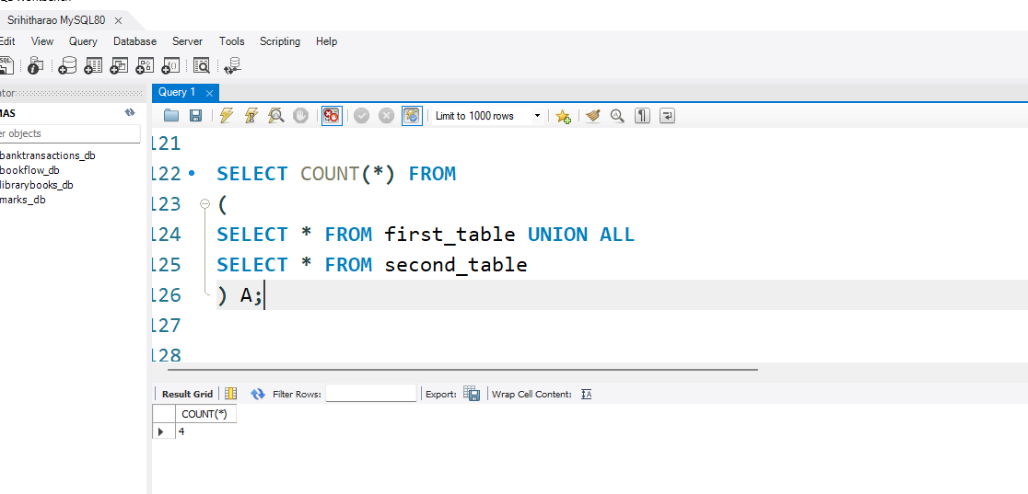
SELECT COUNT(*) FROM
(
SELECT * FROM first_table UNION ALL
SELECT * FROM second_table
) A;

Step 22 — Question 15: INTERSECT
SELECT * FROM first_table INTERSECT
SELECT * FROM second_table;

-- Alternative if INTERSECT is not supported: SELECT f.* FROM first_table f
INNER JOIN second_table s
ON f.id = s.id AND f.name = s.name;

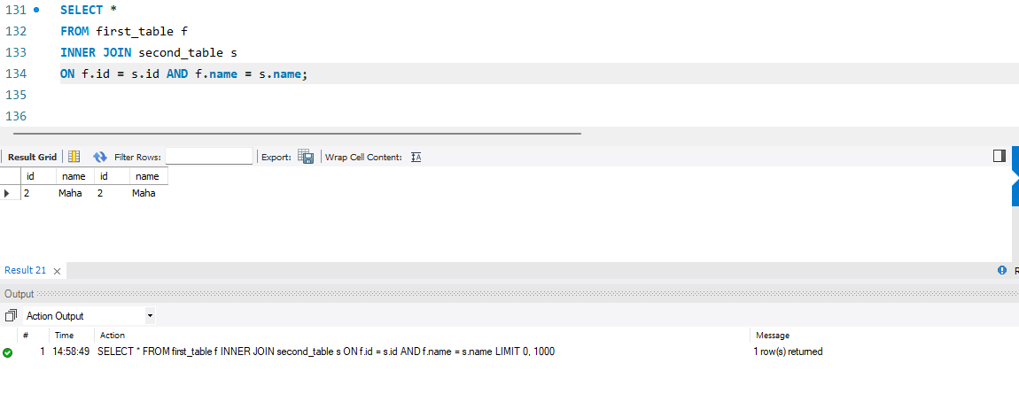

Step 23 — Question 16: INTERSECT (Names Only)
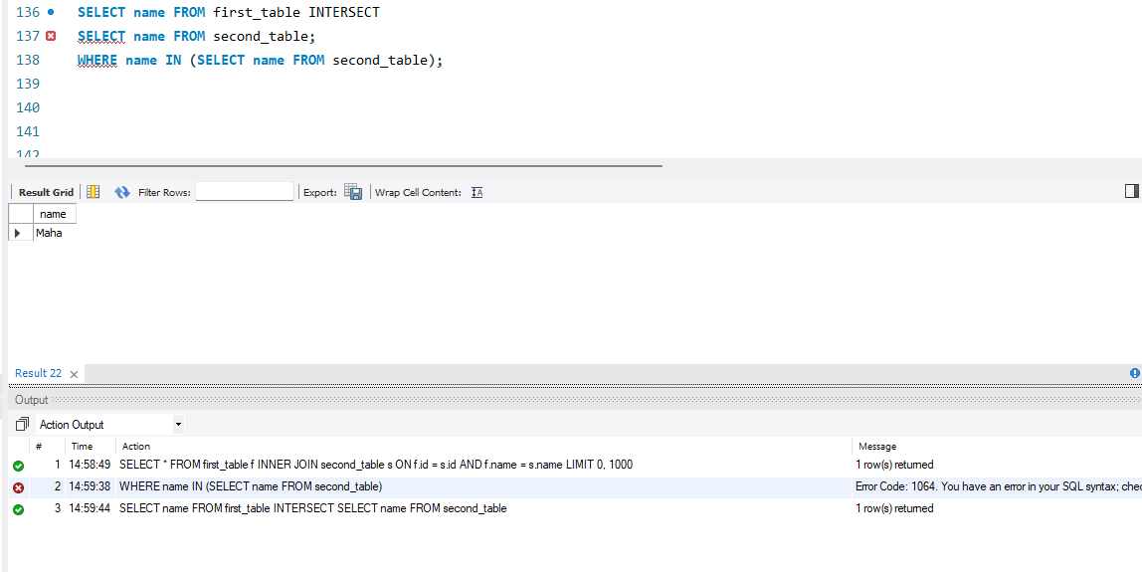
SELECT name FROM first_table INTERSECT
SELECT name FROM second_table;

-- Alternative if INTERSECT is not supported: SELECT name FROM first_table
WHERE name IN (SELECT name FROM second_table);

Step 24 — Question 17: MINUS
-- If your MySQL version supports EXCEPT: SELECT * FROM first_table
EXCEPT
SELECT * FROM second_table;

-- Universal workaround (works on every MySQL version): SELECT f.*
FROM first_table f
LEFT JOIN second_table s
ON f.id = s.id AND f.name = s.name WHERE s.id IS NULL;

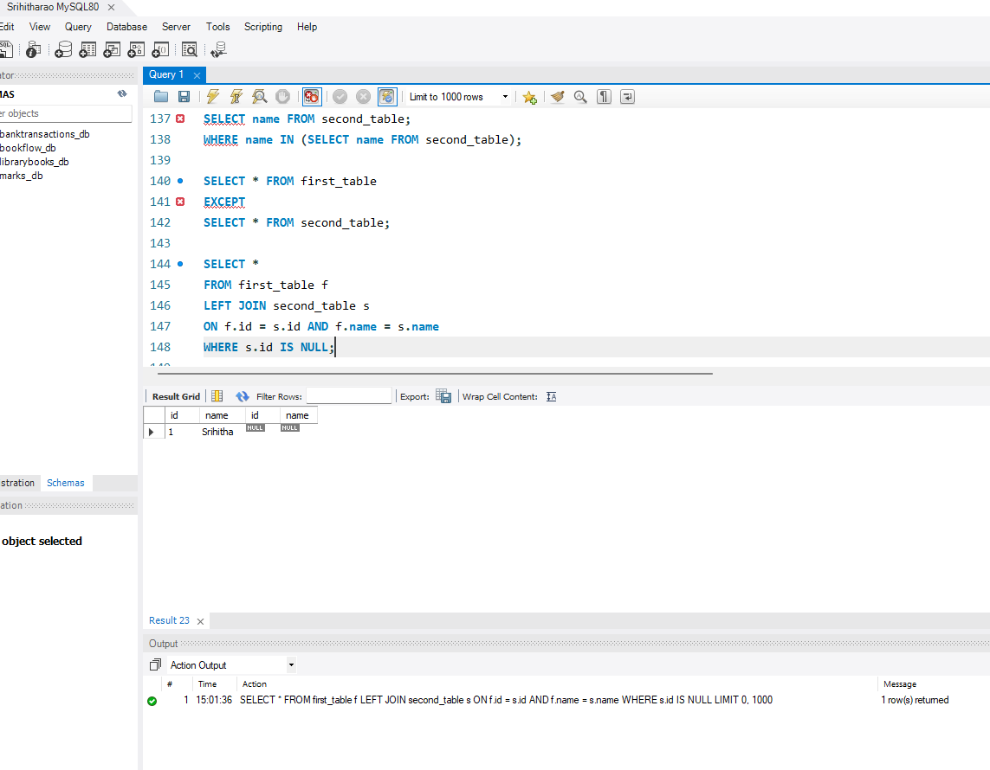

Step 25 — Question 18: MINUS (Names Only)
-- If your MySQL version supports EXCEPT: SELECT name FROM first_table
EXCEPT
SELECT name FROM second_table;

-- Universal workaround:
SELECT name FROM first_table
WHERE name NOT IN (SELECT name FROM second_table);

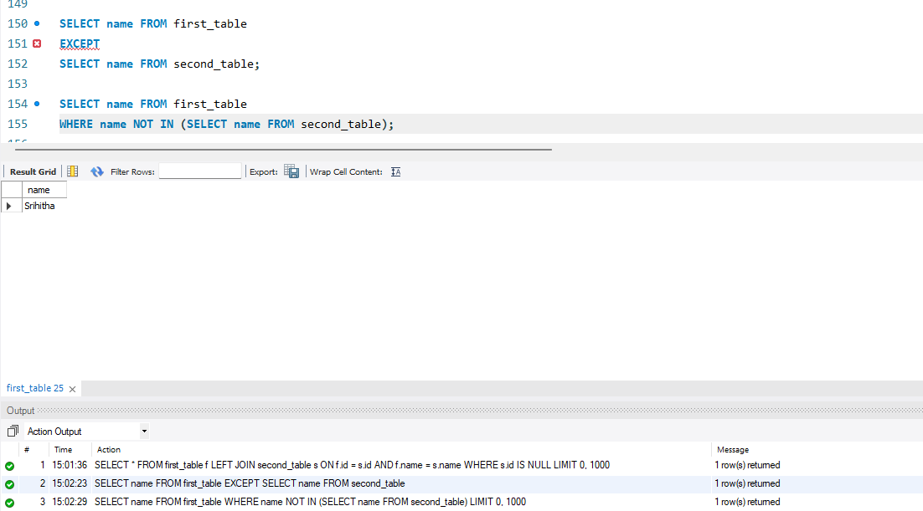

Step 26 — Question 19: Advanced — Matching Addresses
SELECT c.id, c.name, ci.address FROM class c
INNER JOIN class_info ci ON c.id = ci.id;
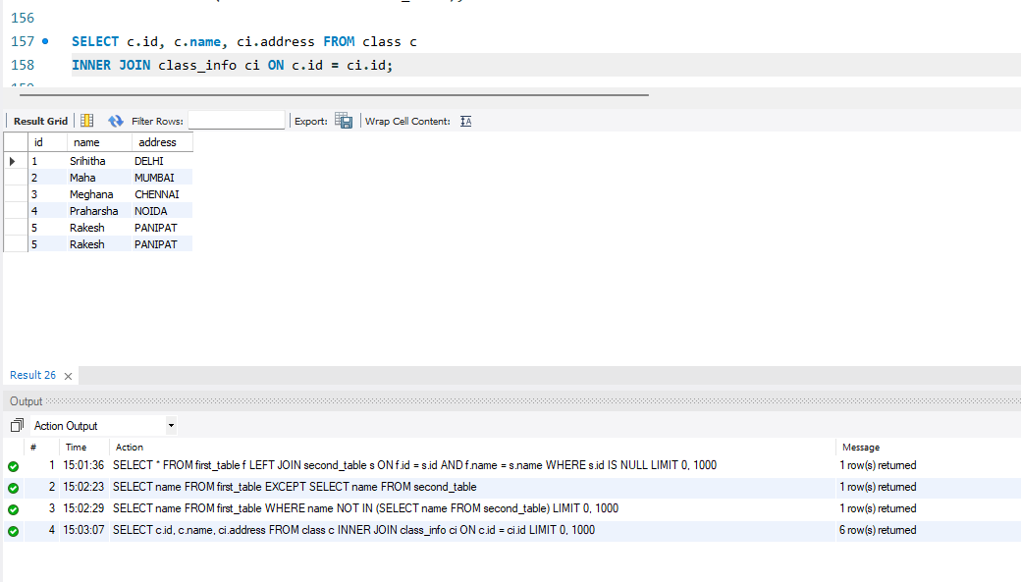

Step 27 — Question 20: Advanced — Address Availability Report
SELECT c.id,
c.name, CASE
WHEN ci.address IS NULL THEN 'Address Missing' ELSE 'Address Available'
END AS Status FROM class c
LEFT JOIN class_info ci ON c.id = ci.id;
